University of Canberra
Faculty of Science and Technology

Software Technology 2
(7170)
Week 11 Tutorial & Computer Lab
Phase 2: Linked List, Trees & Sorting with PyGame

Learning Objectives
- Review of Linked List and Trees Data Structures & Different Sorting Algorithms
- Use PyGame for Linked list editing to insert/delete/reverse with pointer visualization.
- Binary Search Tree visualizer to insert nodes, display traversal orders (in/pre/post).
- Sorting Algorithm Visualizer for bubblesort, selection sort and Merge-Sort.

Task 2_1:
- Objectives
  - Review linked list data structure and its advantages over arrays.
  - Learn how to implement a custom class for singly linked list in Python (add, delete, traverse).
  - Visualize a linked list with nodes and pointers dynamically in PyGame.
- Key Concepts
  - Writing Custom Node class
  - Linkedlist class managing head node.
  - Operations: insert at end, delete node, traverse.
  - Visualization of nodes as circles with arrows (lines) pointing to next.

- Task_2_1.py: Class Activity for Interactive visualization showing insertion of values, deletion by value, and traversal.(not assessed)

- Challenge Task: Modify Task_2_1.py ((assessed as part of Assignment 2-Group Project)
  - Extend the linked list visualization to implement insertion at a specified position.
  - Add a feature to reverse the linked list and animate the reversed linked list display.
  - Allow user keyboard controls to add/delete nodes interactively.

import pygame
import sys

pygame.init()

WIDTH, HEIGHT = 800, 200
screen = pygame.display.set_mode((WIDTH, HEIGHT))
FONT = pygame.font.SysFont(None, 30)
clock = pygame.time.Clock()

NODE_RADIUS = 25

class Node:
def __init__(self, value):
self.value = value
self.next = None

class LinkedList:
def __init__(self):
self.head = None

def append(self, value):
if not self.head:
self.head = Node(value)
return
current = self.head
while current.next:
current = current.next
current.next = Node(value)

def delete(self, value):
current = self.head
prev = None
while current:
if current.value == value:
if prev:
prev.next = current.next
else:
self.head = current.next
return True
prev = current
current = current.next
return False

def to_list(self):
elems = []
current = self.head
while current:
elems.append(current.value)
current = current.next
return elems

def draw_node(x, y, value, highlight=False):
color = (255, 100, 100) if highlight else (100, 200, 250)
pygame.draw.circle(screen, color, (x, y), NODE_RADIUS)
text = FONT.render(str(value), True, (0, 0, 0))
text_rect = text.get_rect(center=(x, y))
screen.blit(text, text_rect)

def draw_arrow(start_pos, end_pos):
pygame.draw.line(screen, (0, 0, 0), start_pos, end_pos, 3)
# Draw a simple arrow head
dx = end_pos[0] - start_pos[0]
dy = end_pos[1] - start_pos[1]
angle = pygame.math.Vector2(dx, dy).angle_to(pygame.math.Vector2(1, 0))
arrow_head = [
(end_pos[0] - 10, end_pos[1] - 5),
end_pos,
(end_pos[0] - 10, end_pos[1] + 5),
]
pygame.draw.polygon(screen, (0, 0, 0), arrow_head)

def draw_linked_list(linked_list, highlight_index=None):
screen.fill((240, 240, 240))
nodes = []
current = linked_list.head
x, y = 80, HEIGHT // 2
idx = 0
while current:
nodes.append((x, y, current.value, idx == highlight_index))
x += 150
current = current.next
idx += 1

for i, (x, y, val, highlight) in enumerate(nodes):
draw_node(x, y, val, highlight)
if i < len(nodes) - 1:
draw_arrow((x + NODE_RADIUS, y), (x + 150 - NODE_RADIUS, y))
pygame.display.flip()

def main():
ll = LinkedList()
actions = [
('append', 5),
('append', 10),
('append', 15),
('delete', 10),
('append', 20)
]

for action, value in actions:
if action == 'append':
ll.append(value)
elif action == 'delete':
ll.delete(value)
for i in range(len(ll.to_list())):
draw_linked_list(ll, highlight_index=i)
pygame.time.wait(500)

pygame.time.wait(2000)
pygame.quit()

if __name__ == '__main__':
main()

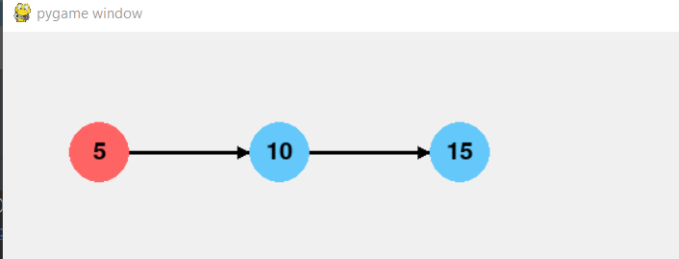
Task 2_1 Challenge Activity (to submit):
Modify Task_2_1.py to:
- Extend the linked list visualization to implement insertion at a specified position.
- Add a feature to reverse the linked list and animate the reversed linked list display.
- Allow user keyboard controls to add/delete nodes interactively.

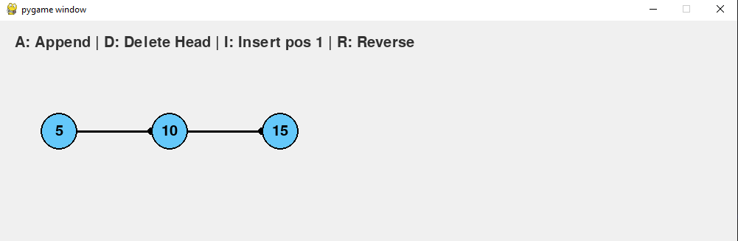

Append 2
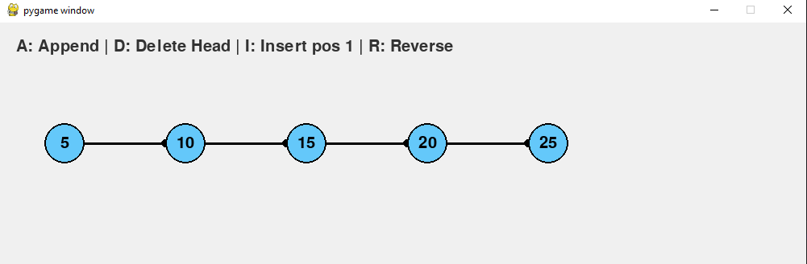

Delete 2
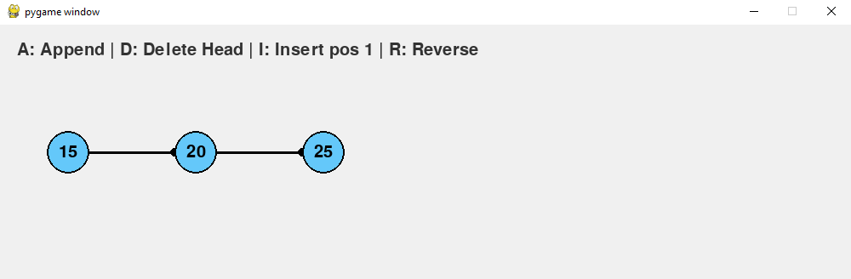

Insert 2 at position 1
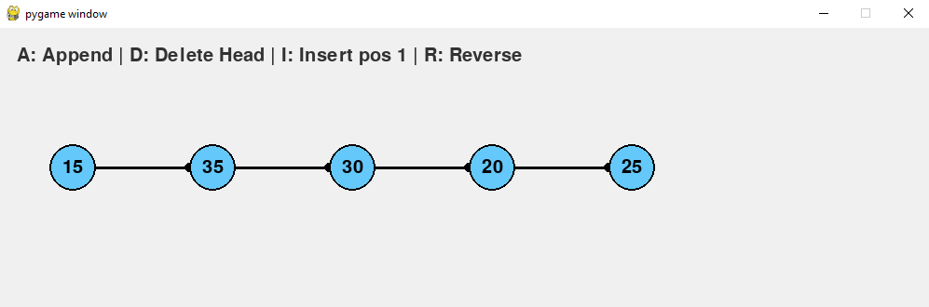

Reverse
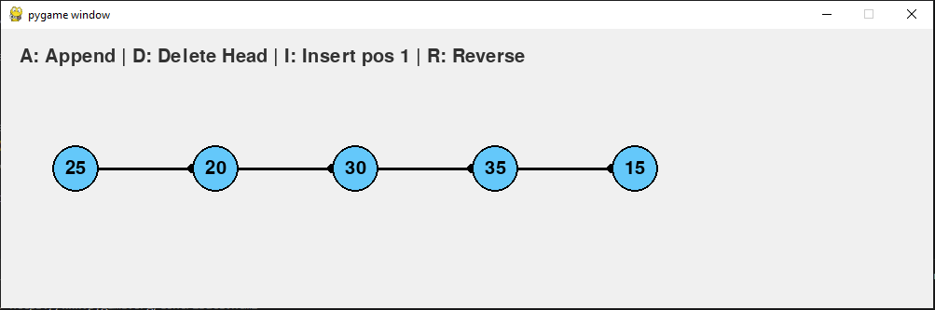

Task 2_2: Extending DSA Playground for Binary Search Tree (BST) -Insert, Delete, Traversals, Visualization
Objectives
- Review BST properties and node insertion/deletion principles.
- Implement recursive insertion and in-order traversal.
- Visualize BST nodes arranged hierarchically with edges, highlight traversal order.
Key Concepts
- BST property: left<node<right
- Recursive methods for insert and delete
- Tree traversal orders: In-order, Pre-order, Post-order
- Tree drawing algorithm (simple recursive positioning)

- Task_2_2.py: Class Activity for inserting nodes with animation, display BST structure.
- Challenge Task: Modify Task_2_2.py (assessed as part of Assignment 2-Group Project)
  - Extend the linked list visualization to implement insertion at a specified position.
  - Add a feature to reverse the linked list and animate the reversed linked list display.
  - Allow user keyboard controls to add/delete nodes interactively.

#==task_2_2.py==
import pygame
import sys

pygame.init()

WIDTH, HEIGHT = 800, 500
screen = pygame.display.set_mode((WIDTH, HEIGHT))
FONT = pygame.font.SysFont(None, 30)
clock = pygame.time.Clock()

NODE_RADIUS = 20

class BSTNode:
def __init__(self, value):
self.value = value
self.left = None
self.right = None

class BST:
def __init__(self):
self.root = None

def insert(self, value):
def _insert(node, value):
if not node:
return BSTNode(value)
if value < node.value:
node.left = _insert(node.left, value)
elif value > node.value:
node.right = _insert(node.right, value)
return node

self.root = _insert(self.root, value)

def inorder(self):
result = []

def _inorder(node):
if node:
_inorder(node.left)
result.append(node)
_inorder(node.right)

_inorder(self.root)
return result

def draw_node(x, y, value, highlight=False):
color = (255, 150, 150) if highlight else (100, 200, 250)
pygame.draw.circle(screen, color, (x, y), NODE_RADIUS)
text = FONT.render(str(value), True, (0, 0, 0))
text_rect = text.get_rect(center=(x, y))
screen.blit(text, text_rect)

def draw_edge(start_pos, end_pos):
pygame.draw.line(screen, (0, 0, 0), start_pos, end_pos, 3)

def draw_tree(node, x, y, x_offset, nodes_pos, parent_pos=None):
if node:
nodes_pos[node] = (x, y)
if parent_pos:
draw_edge(parent_pos, (x, y))
# Draw left subtree
draw_tree(node.left, x - x_offset, y + 80, x_offset // 2, nodes_pos, (x, y))
# Draw right subtree
draw_tree(node.right, x + x_offset, y + 80, x_offset // 2, nodes_pos, (x, y))
draw_node(x, y, node.value)

def main():
bst = BST()
values = [50, 30, 70, 20, 40, 60, 80]
for v in values:
bst.insert(v)

running = True
highlight_idx = 0
inorder_nodes = bst.inorder()

while running:
screen.fill((240, 240, 240))
draw_tree(bst.root, WIDTH // 2, 50, 150, {})
# Highlight current node in in-order traversal
if highlight_idx < len(inorder_nodes):
node = inorder_nodes[highlight_idx]
x, y = WIDTH // 2, 50
# We need to find node position (roughly)
# For simplicity, redraw tree and highlight the node:
nodes_pos = {}

def store_positions(node, x, y, x_offset, parent_pos=None):
if node:
nodes_pos[node] = (x, y)
store_positions(node.left, x - x_offset, y + 80, x_offset // 2, (x, y))
store_positions(node.right, x + x_offset, y + 80, x_offset // 2, (x, y))

store_positions(bst.root, WIDTH // 2, 50, 150)
if node in nodes_pos:
draw_node(*nodes_pos[node], node.value, highlight=True)

for event in pygame.event.get():
if event.type == pygame.QUIT:
running = False

pygame.display.flip()
clock.tick(1) # 1 frame per second to see step-by-step
highlight_idx += 1
if highlight_idx > len(inorder_nodes):
highlight_idx = 0

pygame.quit()

if __name__ == "__main__":
main()

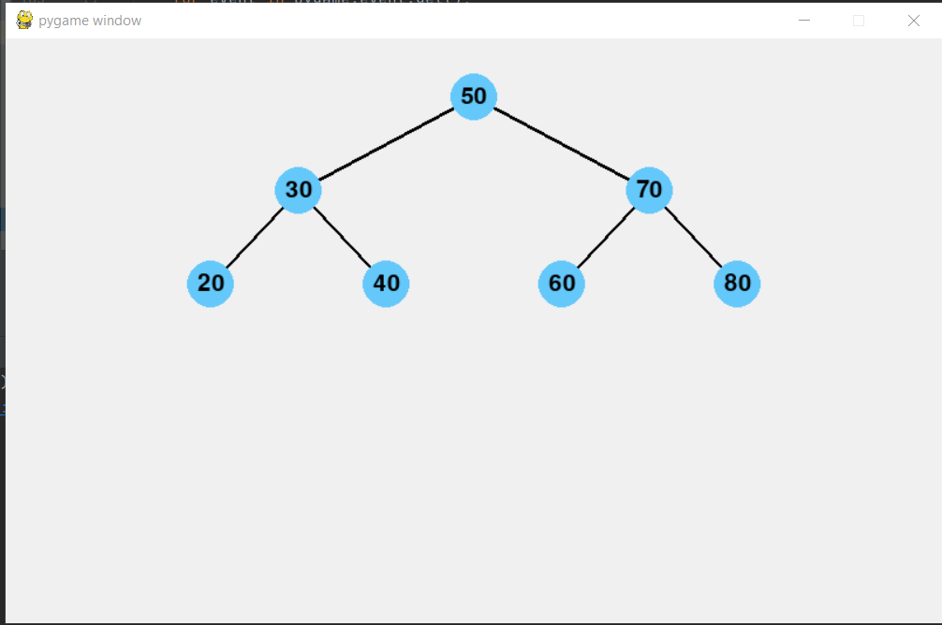
- Task_2_ 2 Challenge Activity (To submit):
Modify task_2_2.py to:
- Implement pre-order and post-order traversal methods and add visualization.
- Add a feature to search for a node in BST and highlight the path it takes.
- Implement node deletion (handle 0,1,2 child cases) and update visualization.

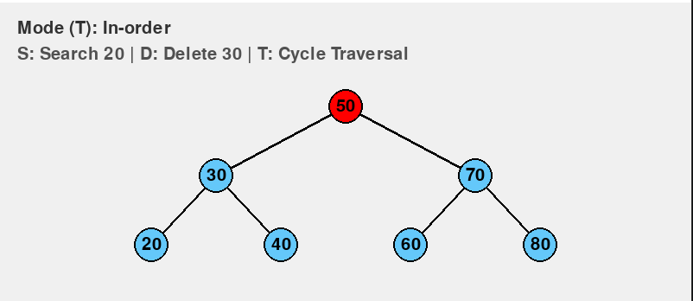

Search for 20
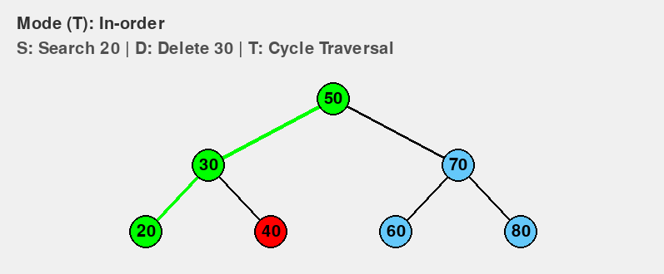

Search for 70
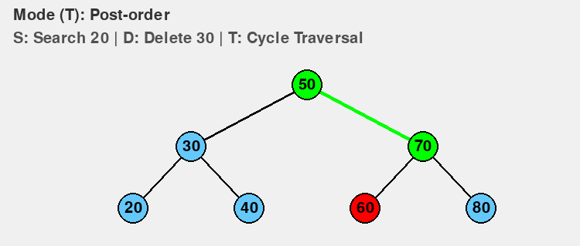

Delete 30
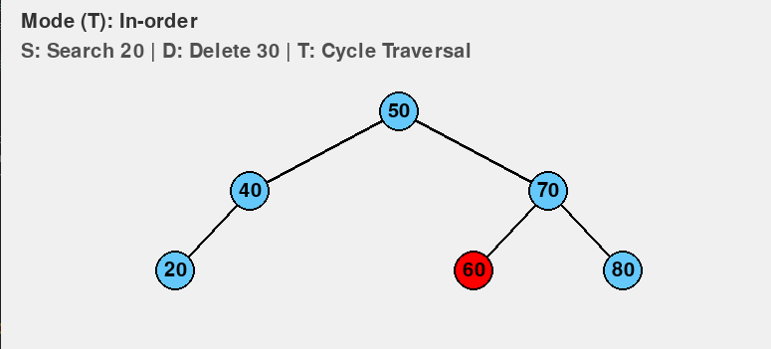

Task 2_3: Extending DSA Playground for Visualising Sorting Algorithms

Objectives
- Review basic sorting algorithms: bubble sort, selection sort, and merge sort concepts and complexity.
- Implement these sorting algorithms with Python Pygame Interface.
- Visualize sorting on an array with bars, highlighting compared/swapped elements.
Key Concepts
- Sorting algorithms step-by-step execution.
- Visual feedback for comparisons and swaps.
- Recursive sorting (merge sort) visualization concept.
- Task_2_3.py: Class Activity to Visualize bubble sort on a random list.
- Challenge Task: Modify Task_2_3.py (assessed as part of Assignment 2-Group Project)

#==task_2_3.py==
import pygame
import random
import sys

pygame.init()

WIDTH, HEIGHT = 600, 400
screen = pygame.display.set_mode((WIDTH, HEIGHT))
FONT = pygame.font.SysFont(None, 24)
clock = pygame.time.Clock()

ARRAY_SIZE = 30
array = [random.randint(10, 350) for _ in range(ARRAY_SIZE)]
bar_width = WIDTH // ARRAY_SIZE

def draw_array(array, color_positions=None):
screen.fill((30, 30, 30))
for i, val in enumerate(array):
color = (100, 200, 250)
if color_positions and i in color_positions['compare']:
color = (255, 100, 100)
if color_positions and i in color_positions['swap']:
color = (100, 255, 100)
pygame.draw.rect(screen, color, (i * bar_width, HEIGHT - val, bar_width - 2, val))
pygame.display.flip()

def bubble_sort_visualize(array):
n = len(array)
for i in range(n):
for j in range(0, n - i - 1):
draw_array(array, {'compare': [j, j + 1], 'swap': []})
pygame.time.wait(50)
for event in pygame.event.get():
if event.type == pygame.QUIT:
pygame.quit()
sys.exit()
if array[j] > array[j + 1]:
array[j], array[j + 1] = array[j + 1], array[j]
draw_array(array, {'compare': [], 'swap': [j, j + 1]})
pygame.time.wait(50)
draw_array(array)

def main():
draw_array(array)
pygame.time.wait(1000)
bubble_sort_visualize(array)
pygame.time.wait(2000)
pygame.quit()

if __name__ == "__main__":
main()

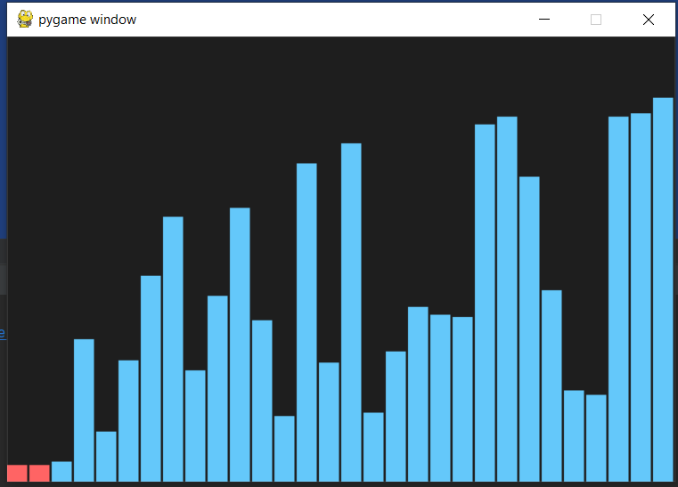

- Task_2_ 3 Challenge Activity (To submit):
Modify task_2_3.py to:
• Implement selection sort visualization similar to bubble sort.
• Implement merge sort visualization (show splits and merges).
• Add buttons to select which sorting algorithm to run.

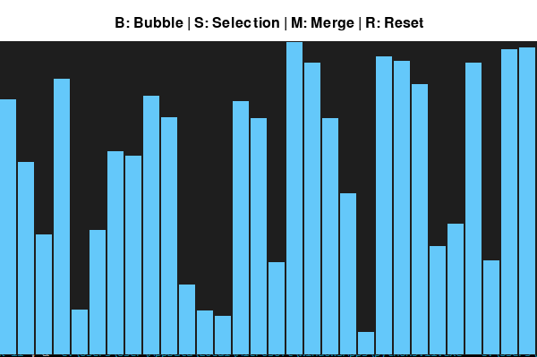

Bubble sort
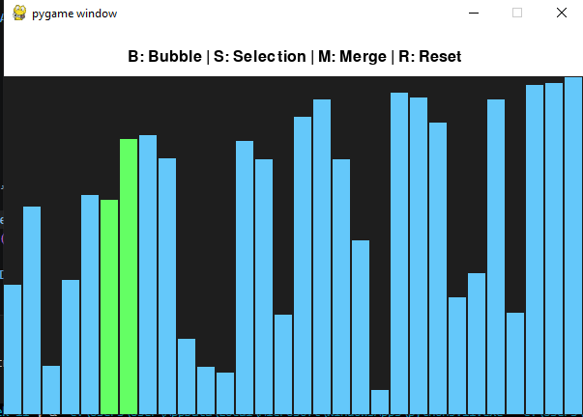
Selection sort
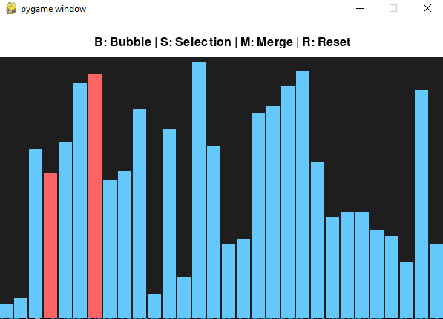

Merge sort
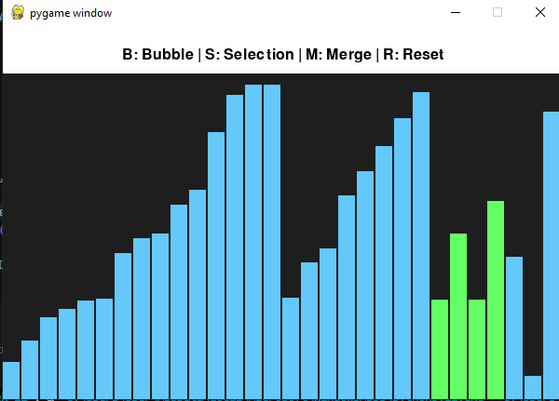

Submission requirements from Week 11 tutorial tasks for Assignment 2-Group Project
Phase 2 Tasks | Tasks for learning (not assessed) | Tasks for Submission (assessed
2.1 | Linked List: Implementation & Visualization | Insert at position, reverse list, interactive controls
2.2 | BST: Insert, Traversals, Visualization | Pre/post-order traversal, search highlight, deletion
2.3 | Bubble Sorting Algorithm Visualization | Selection sort, merge sort visualization, UI buttons

